Population Growth Rate Modeling
Drew Padrta
Washington State University
October 23, 2017

Taxus brevifolia, the Pacific Yew is a conifer native to the Pacific Northwest of North America. This tree species ranges from the southernmost tip Alaska, down to central California. Its population is also found in Pacific Coast Ranges with others in British Columbia. Taxus brevifolia is not a tree but a shrub variety. Its distinguishing feature is its flexible step which can creep on the ground for a short distance before going up as shown in figure 1. Furthermore, its branches grow off from the stem, specifically the upper side as shown in figure 2. The species has been given another name reptaneta which means a creeping plant (Busing et al., 1995). 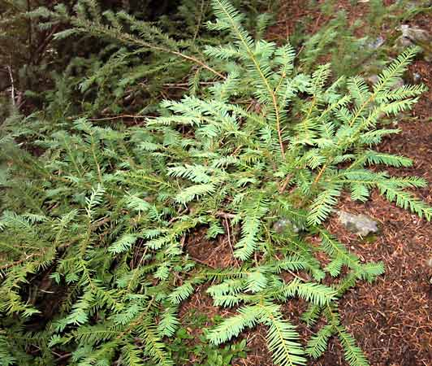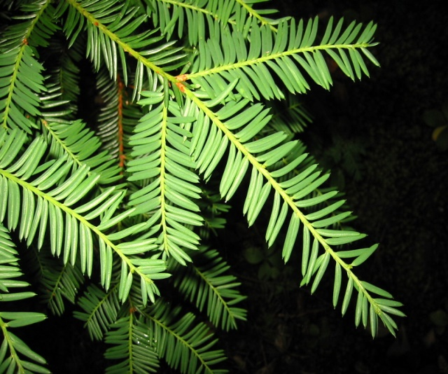
Figure 1
Figure 2
The species also occur along the forest margins in some parts of northwestern Montana, the thicket yew plants do not ascend but rather stay on the ground as shown in figure 3. The form depicts the original or the ancestral form which assumes the upright nature with the branches on the upper side. The pattern evolves from one stem to the other as it develops the upright position from the creeping one. The species has an economic importance because it is used in the synthesis of an anti-cancer drug called Taxol. Taxol is very useful in killing cancer tumors hence making the plant very useful (More about Taxol is found under ‘Economic Importance’) (Schiff et al., 1979).
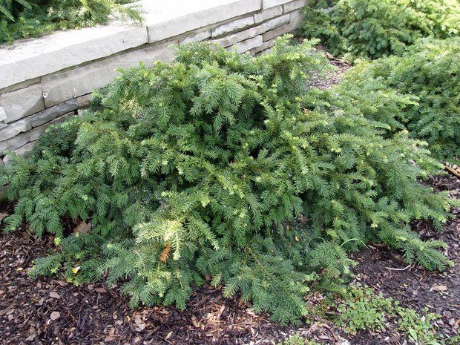
Figure 3
Characteristics
The Pacific yew is a small-medium evergreen tree. It has a typical maximum height of 10-15 m with a thin trunk of 50 cm. However, the species has been found to grow to 20 m tall taking place only in the parks and other preserved areas. The species has a redundant growth behavior with a tendency of rotting from inside as it develops. This characteristic makes it difficult for the species to form the rings which may give an accurate determination of the age. The tree grows a thin, scaly brown bark as shown in figure 4 which provides the cover to a thin layer of off-white sapwood with darker heartwood which shows variation in color from brown to a purplish hue (Busing et al., 1995).
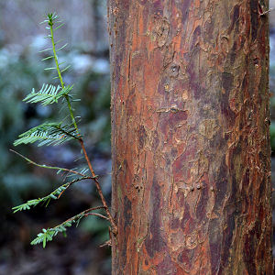
Figure 4
Reproductive Cycle
The Pacific yew has separate male and female parts. Therefore, the seeds are produced and forced to travel for germination. Birds play an integral role in the seeds dispersal process (DiFazio et al., 1998). The seeds are produced on the female tree while the pollen grains are developed on the male tree. The general life cycle begins from fertilization of the seed which forms a sporophyte that undergoes meiosis to form the megaspores (DiFazio et al., 1996). Eventually, it develops the megagametophytes and microgametophytes respectively. Also, the megagametophytes produce the egg while the microspores produce sperm. Fertilization occurs once again to restart the cycle (Walters-Vertucci et al., 1996) 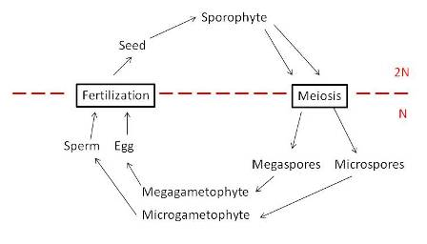
Ecological Importance
Through interaction with other species, the plant can provide food for the foraging animals like whitetail deer, elk, and mouse. The fruits produced by the Pacific yew are eaten by ring-tailed cat and songbirds. However, the relationship is mutually beneficial since the birds feeding on the fruits can aid in seed dispersal (Stierle et al., 1994). The species has an economic importance because it is used in the synthesis of an anti-cancer drug called Taxol. Taxol (paclitaxel) is an essential natural diterpenoid alkaloids separated from the bark of the Pacific yew (Wani et al., 1971). Taxol has been praised as having provided most of the significant advances in cancer therapy. Its plaudits are majorly attributed to its ability to kill tumor cells by enhancing the assembly of microtubules and inhibiting their depolymerization (Schiff et al., 1979). It has been well established and approved by FDA (the Food and Drug Administration) as a beneficial chemotherapeutic agent against a wide range of tumors since 1992 (Kohler & Goldspiel, 1994).
Demographic Matrix Model
Stage | <0.5 m tall | 0.5-1.0 m tall | <= 1 cm DBH | 1-4.9 cm DBH | 5-14.9 cm DBH | 15-24.5 cm DBH | >= 25 cm DBH
<0.5 m tall | 0.88 | 0 | 0 | 0.12 | 0.16 | 0.2 | 0.24
0.5-1.0 m tall | 0.09 | 0.88 | 0 | 0 | 0 | 0 | 0
<=1 cm DBH | 0 | 0.08 | 0.89 | 0 | 0 | 0 | 0
1-4.9 cm DBH | 0 | 0 | 0.07 | 0.97 | 0 | 0 | 0
5-14.9 cm DBH | 0 | 0 | 0 | 0.025 | 0.792 | 0 | 0
15-24.9 cm DBH | 0 | 0 | 0 | 0 | 0.005 | 0.99 | 0
>= 25 cm DBH | 0 | 0 | 0 | 0 | 0 | 0.009 | 0.993
Fig 5; stages of growth of the Pacific yew plant and the size of the plant at different stages in its life cycle, it can also be used to help predict the populations at certain points in a life cycle which is good for conservation biologists looking to save or extinguish species
This model displays the size and population of the yew plant at different stages of its lifecycle. The parameters involved include L which represents the mean length of the plants (also referred to as asymptotic length). t represents the age of the plant, K (the curvature parameter) determines how fast the plant approaches L, t0 (the initial condition parameter) determines the point in time when the plant has zero length. The data is broken down into 7 stages <.5 m tall, 0.5-1.0 m tall, <1cm DBH, 1-4.9 cm DBH, 5-14.9 cm DBH, 15-24.9 cm DBH, > 23 cm DBH arranged along the Y-axis, and size in cm along the X-axis as well as years. I started with the initial population of 500 seedlings and ran the model for 70 years to see what would happen to the overall population. As shown in Fig 6, there was a decrease in population in the course of the first 20 years as the seeding through the different growth cycles and started to produce their viable offspring. You see this on the model with the larger trees starting at less than one on the logarithmic scale. After that, you can see that the population has continued to grow finally approaching a stable stage distribution at year 70. At this point, there are a similar number of all sizes of yews. When the population reached SSD, the lambda value was 1.022, which proves that our population is increasing. Since the SSD and the associated growth rate are a function of the matrix values, the SSD and its associated lambda are reached when the matrix rates become relatively constant. If we were to run this model for a few hundred years, I think that the population would have a lambda value greater than 1, with no K (Infinite population size) thus becoming unrealistic. Depending on where these yews are located they could be in a somewhat small area, and as the population continues to increase, its competitive inhibition begins to take place hence lowering fitness (Hao et al., 2005).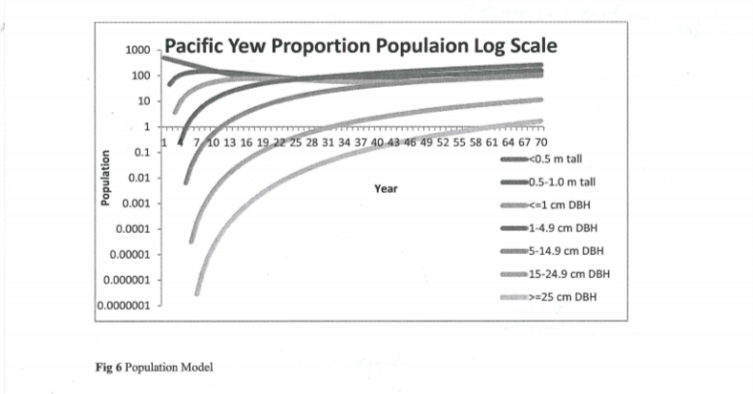
Elasticity
An elasticity matrix was conducted using a 10% increase to each of the original model parameters to see which would have the most significant impact on the total population growth rate. This increase had the most significant effect in the trees between 1-4.9 cm DBH with a rise of 7.55% and 5-14.9 cm DBH with an increase of 8.78%. The smallest impact of the increased elasticity was the tiny trees (<0.5 m tall) which had a 2% increase. The population growth rate is lower in smaller trees because of a high intraspecific competition and the interdependence on canopy gaps for their successful establishment. Over time, the population is growing, and it took 20 years for the smaller trees to start being able to reproduce hence the registered change in elasticity. The other minor impact affected the large trees; only 1% of the population falls under this category, so this made little impact at this stage.
Stage | <0.5 m tall | 0.5-1.0 m tall | <= 1 cm DBH | 1-4.9 cm DBH | 5-14.9 cm DBH | 15-24.5 cm DBH | >= 25 cm DBH
<0.5 m tall | 1.03778 | 0 | 0 | 1.02279 | 1.0229 | 1.0227 | 1.02217
0.5-1.0 m tall | 1.02368 | 1.03765 | 0 | 0 | 0 | 0 | 0
<=1 cm DBH | 0 | 1.02367 | 1.3946 | 0 | 0 | 0 | 0
1-4.9 cm DBH | 0 | 0 | 1.02366 | 1.07628 | 0 | 0 | 0
5-14.9 cm DBH | 0 | 0 | 0 | 1.0416684 | 1.0886 | 0 | 0
15-24.9 cm DBH | 0 | 0 | 0 | 0 | 1.02232 | 1.04405 | 0
>= 25 cm DBH | 0 | 0 | 0 | 0 | 0 | 1.02217 | 1.02478
Figure 8; Lambda values after a 10% increase in elasticity

Stage | <0.5 m tall | 0.5-1.0 m tall | <= 1 cm DBH | 1-4.9 cm DBH | 5-14.9 cm DBH | 15-24.5 cm DBH | >= 25 cm DBH
<0.5 m tall | 3.70% | 0 | 0 | 2.20% | 2.21% | 2.19% | 2.14%
0.5-1.0 m tall | 2.29% | 3.69% | 0 | 0 | 0 | 0 | 0
<=1 cm DBH | 0 | 2.29% | 3.87% | 0 | 0 | 0 | 0
1-4.9 cm DBH | 0 | 0 | 2.29% | 7.55% | 0 | 0 | 0
5-14.9 cm DBH | 0 | 0 | 0 | 4.09% | 8.78% | 0 | 0
15-24.9 cm DBH | 0 | 0 | 0 | 0 | 2.15% | 4.33% | 0
>= 25 cm DBH | 0 | 0 | 0 | 0 | 0 | 2.14% | 2.40%
Figure 9; The Percent difference after the change in elasticity

Using the model to manage the species
It’s a crisp spring afternoon, and I was just tasked with this new species my boss wants to bring to Pullman Washington called Pacific Yew. He has given me 500 seedlings, and it is my job to manipulate their growth so that the population remains constant or maintain a lambda value of 1. Fig 5 shows the starting matrix for the population, and through modeling, I was able to after 70 years get it to a stable population growth rate with a lambda value of 1.2. When I started manipulating the numbers, I found that if I lowered the elasticity of only two parameters I was able to maintain a lambda value of exactly 1. The 1st stage I would reduce the elasticity at would be <.5 m tall by 7%; at this early stage, it would be easier to alter the growing patterns since a good percentage won’t even make it to being a large tree. This could be done in some ways; from spraying some with herbicides to covering them with more soil or another type of earth that would slow down the growing process as it must work its way back up through it, some would make it and some wouldn’t. This could be done for the first year and see if it works the way we wanted it to or if it killed off all or none of the little seedlings. In doing it this way, we are not deliberately killing any young yew trees, and it can be relatively inexpensive depending on the material used. The second stage of growth that I would lower the elasticity of the 5-14.9 cm trees. Reducing the elasticity by 10% it brings us to a lambda value of 1.00001 which is precisely what we were looking for as shown in Fig 9. To lower this elasticity group, we would prune it all the way back to its stem. This will decrease its ability to start reproducing which in return reduces its elasticity ("can you prune pacific yew trees - Yahoo Video Search Results," 2017). Yews are very tolerant of pruning, so this would avoid us having to kill plants and should be relatively inexpensive. These two manipulations enable us to lower the growth rate while limiting any mortality which is very helpful since it leads to a lambda value of 1.
Stage | <0.5 m tall | 0.5-1.0 m tall | <= 1 cm DBH | 1-4.9 cm DBH | 5-14.9 cm DBH | 15-24.5 cm DBH | >= 25 cm DBH
<0.5 m tall | 0.8284 | 0 | 0 | 0.12 | 0.16 | 0.2 | 0.24
0.5-1.0 m tall | 0.091 | 0.88 | 0 | 0 | 0 | 0 | 0
<=1 cm DBH | 0 | 0.08 | 0.89 | 0 | 0 | 0 | 0
1-4.9 cm DBH | 0 | 0 | 0.07 | 0.97 | 0 | 0 | 0
5-14.9 cm DBH | 0 | 0 | 0 | 0.025 | 0.792 | 0 | 0
15-24.9 cm DBH | 0 | 0 | 0 | 0 | 0.005 | 0.99 | 0
>= 25 cm DBH | 0 | 0 | 0 | 0 | 0 | 0.009 | 0.993
Figure 9

In a nutshell, it can be brought out that Taxus brevifolia varies from one stage to another. It is equally important to know that not all the seedlings survive to the adult stage. Correspondingly, these variations of growth rate in each stage provide an advantage in the management of these species. Through this modeling, we have been able to prove the Pacific yew population is increasing at a stable population growth rate after 70 years. Data was also provided showing how to maintain a constant population.

References
Hao, Q., Meng, F., Zhou, Y., & Wang, J. (2005). Determining the optimal selective harvest strategy for mixed-species stands with a transition matrix growth model. New Forests, 29(3), 207-219.
DiFazio, S. P., Wilson, M. V., & Vance, N. C. (1996). Variation in sex expression of Taxus brevifolia in western Oregon. Canadian Journal of botany, 74(12), 1943-1946.
Busing, R. T., Halpern, C. B., & Spies, T. A. (1995). Ecology of Pacific yew (Taxus brevifolia) in western Oregon and Washington.Conservation Biology, 9(5), 1199-1207.
Difazio, S., Wilson, M., & Vance, N. (1998). Factors limiting seed production of Taxus brevifolia (Taxaceae) in Western Oregon.American Journal of Botany, 85(7), 910-910.
Stierle, A., Stierle, D., Strobel, G., Bignami, G., & Grothaus, P. (1994). Endophytic fungi of Pacific yew (Taxus brevifolia) as a source of taxol, taxanes, and other pharmacophores.
Walters‐Vertucci, C., Crane, J., & Vance, N. C. (1996). Physiological aspects of Taxus brevifolia seeds in relation to seed storage characteristics. Physiologia plantarum, 98(1), 1-12.
Wani, M. C., & Taylor, H. L. (1971). Plant antitumor agents. VI. The isolation and structure of taxol, a novel antileukemia and antitumor agent from [the stem bark of] Taxus brevifolia. Journal of the American Chemical Society, 93(9), 2325-7.
Schiff, P. B., Fant, J., & Horwitz, S. B. (1979). Promotion of microtubule assembly in vitro by taxol. Nature, 277(5698), 665-667.
Kohler, D. R., & Goldspiel, B. R. (1994). Paclitaxel (taxol).Pharmacotherapy: The Journal of Human Pharmacology and Drug Therapy, 14(1), 3-34.
can you prune pacific yew trees - Yahoo Video Search Results. (2017). Video.search.yahoo.com. Retrieved 25 October 2017, from https://video.search.yahoo.com/search/video?fr=spigot-chr-gcmac&p=can+you+prune+pacific+yew+trees#id=2&vid=ec505a64406af9e19becfb7ebc05cdb8&action=click

